ΘΕΜΑ 1. ΚΑΤΑΝΟΗΣΗ ΓΡΑΠΤΟΥ ΛΟΓΟΥ
Read the text and decide if each statement (1-10) is True (A), False (B) or Not Mentioned (C).

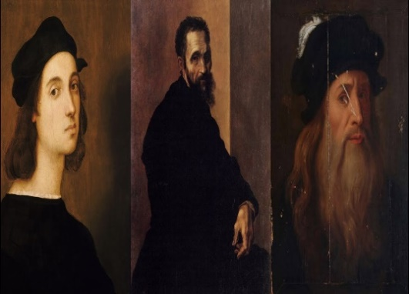
Raphael was born on March the 28th or April the 6th, 1483. His father, Giovanni Santi, was a skilful painter and was highly appreciated in Urbino, a region that housed one of the most glittering courts in Italy. This provided the young Raffaelo with quite a privileged upbringing within the culture of the Umbrian court. However, Raphael's mother dies in 1491 when he is eight years old. His father, Giovanni, dies three years later when he is still only eleven. Before his death, Giovanni manages to place his son as a trainee in the art studio of Pietro Perugino. Although Raphael very quickly escaped from the painting style of his trainer, he followed Perugino's method of constructing paintings all of his life.
Raphael's move to Florence in 1504 was stimulated by his strong wish to learn more from the recognized great representatives of Florentine art. Leonardo da Vinci was at the peak of his fame and had returned to the city from Milan in 1500. Raphael copied figures by Leonardo and Michelangelo who had both studied the anatomy of the human body. In Florence, Raphael also completed three large pieces for inner church parts, The Ansidei Madonna, The Baglioni altarpiece, both commissioned by Perugian clients, and The Madonna del Baldacchino for a chapel in Santo Spirito, a Florentine church. One of his final paintings of the Florentine period is the magnificent Saint Catherine now in the National Gallery in London. Raphael was able to continue with his own developing style whilst absorbing the influences of Florentine art. At the age of 25, he found a patron, Pope Julius II, and was given the task of decorating rooms in the Pope's private apartments. The Stanza also known as the Raphael Rooms, are located on the upper floor of the Vatican Palace.
(Words: 300)

Statements |  | A | B | C
 |  | TRUE | FALSE | NOT MENTIONED
 | Raphael’s father did not appreciate art at all.
 | The text suggests that the Umbrian court promoted the arts.
 | Raphael imitated Perugino’s painting style throughout his artistic career.
 | Giovanni Santi arranged Raphael’s training next to Perugino for a period of three years.
 | Raphael moved to Florence to learn more about contemporary Florentine art.
 | In his creations, Raphael adopted figures from other painters’ works.
 | Raphael created paintings on the walls of one church in Milan.
 | Raphael’s works can only be admired in Italy.
 | Florentine art played no role in the development of Raphael’s unique painting style.
 | Some of the Pope’s private apartments were decorated by Da Vinci and Michelangelo.

ΘΕΜΑ 2^{α}. ΛΕΞΙΚΟΓΡΑΜΜΑΤΙΚΗ
Use the correct form of the following words (A-K) to complete the gaps (11-20) as in the example.
A. | culture | B. | manages | C. | national | D. | place | E. | style | F. | known
G. | move | H. | dies | I. | magnificent | J. | highly | K. | young

EXAMPLE | In Oscar Wilde’s novel “The Picture of Dorian Gray”, the hero exchanges his soul for eternal YOUTH. According to Dorian’s wish his portrait ages but he does not.
 | Deliberate killings, mass bombings, diseases and hunger caused the ____ of over 60 million people during World War II.
 | I guess the fact that she has excellent ____ of French and German was highly considered for her promotion to chief receptionist.
 | No matter the place where I decide to spend my holidays, I always attend any ____ events organized by the local authorities such as dance festivals and theatrical performances.
 | Both girls are so elegant! They always wear the most ____ clothes you can think of.
 | According to latest calculations, the ____ of Mount Everest has increased nearly a meter over the past decades due to geological changes.
 | A theatre production ____ is responsible for hiring crew members and resolving any issues that threaten to slow progress towards the opening night of a play.
 | Feeling excited about the ____ of the different planets around the sun since he was a little boy, he decided to study astronomy.
 | Any time you realize you have purchased a faulty product, you should take it back to the store and ask for a refund or ____.
 | All actors and actresses performed ____ and received the warmest signs of approval by the audience.
 | An international school offers multi-faceted education to students of different ____ who come from different countries and may speak a range of different languages.

