ΘΕΜΑ 1. ΚΑΤΑΝΟΗΣΗ ΓΡΑΠΤΟΥ ΛΟΓΟΥ
Read the text and choose the correct option (A, B or C) for items 1-10.
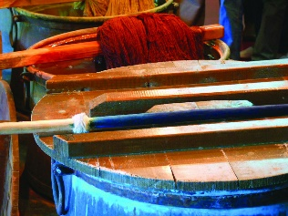
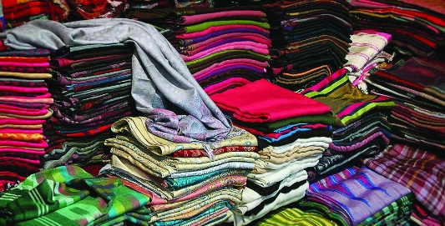
Criticisms of fast fashion include its environmental impact, the use of toxic chemicals and increasing levels of textile waste. So, how can consumers reduce the environmental cost of fast fashion when out shopping? Choosing an eco-friendly fabric is complex as there are pros and cons to all fibre types. Clothes labelled as being made from natural fibres are not necessarily better than synthetic ones. Choosing organic fabrics is better than choosing non-organic fabrics in terms of the chemicals used to grow the fibres, but organic cotton still requires high amounts of water and the impact of dyeing is higher than the impact of dyeing polyester. Recycled content is often the best of all, as it tackles the growing problem of waste management. For example, Patagonia was the first outdoor clothing brand to make polyester fleece out of plastic bottles. From spring 2018, it will be offering only two fabric options of either 100 per cent organic cotton or a blend of recycled cotton and recycled polyester, recognising that even organic cotton has a negative environmental impact. The Love Your Clothes initiative from the charity Wrap gives information for consumers on each stage of the purchase process, from buying smarter to repairing items, to making changes to meet new needs and finally responsible disposal. The best thing we can do is to keep our clothing in use for longer and buy less new stuff.
(Words: 233)
1. | The main purpose of the text is to
 | A. | describe how fast fashion harms the environment. |  | B. |  | advise shoppers on how they can protect the environment. | C. | warn consumers against buying non-organic fabrics.
2. | This text could most probably be found in a(n)
 | A. | newspaper. |  | B. |  | fashion leaflet. | C. | online catalogue.
3. | When buying clothes
 | A. | choosing the ones made from natural fibres is the best option. |  | B. |  | choosing the ones made from natural fibres is the worst option. | C. | it is not easy to choose the most environmentally-friendly fabric.
4. | According to the text,
 | A. | no chemicals are used to grow non-organic fibres. | B. |  | dyeing polyester is more harmful than dyeing cotton. |  | C. | a lot of water is used to grow organic cotton.
5. | According to the text, recycling clothes
 | A. | leads to the creation of new production methods. | B. |  | can have a positive environmental impact. |  | C. | is the only way to reduce environmental pollution.
6. | Patagonia is an outdoor clothing brand that
 | A. | does not make its fabrics by mixing polyester with cotton. | B. |  | admits that even organic cotton can harm the environment. |  | C. | does not use any pure organic cotton fabrics.
7. | The Love Your Clothes initiative
 | A. | gives advice on buying and caring for clothes. | B. |  | offers seminars on how to repair old clothes. |  | C. | donates unwanted clothes to homeless people.
8. | In the text, the underlined word “tackles” means
 | A. | presents. | B. |  | beats. |  | C. | deals with.
9. | In the text, the underlined phrase “responsible disposal” means
 | A. | showing good judgement when throwing clothes away. | B. |  | getting rid of old clothes without any second thoughts. |  | C. | repairing old clothes in a responsible manner.
10. | A possible title for this text would be
 | A. | Fast Fashion For All! | B. |  | What Shoppers Can Do! |  | C. | Mistakes Shoppers Make!

ΘΕΜΑ 2^{α}. ΛΕΞΙΚΟΓΡΑΜΜΑΤΙΚΗ
Fill each gap in sentences 11-20 with the correct word from the box below (A-J). Use each word only once.
A. | impact (n.) | B. | reduce | C. | complex | D. | natural | E. | consumers
F. | content | G. | resources | H. | growing | I. | purchase (n.) | J. | process

No ______ of the product is necessary for you to enter this competition.
The anti-smoking campaign seems to have made a(n) ______ on young people.
Floods and earthquakes are ______ disasters.
Making mistakes is an important part of the learning ______.
Some families do not even have the basic ______ to feed themselves properly.
The film’s plot was so ______ that I couldn't follow it.
There is a(n) ______ number of women in high-profile positions in the government these days.
The plane will______ speed as soon as it approaches the airport.
Unfortunately, the extra costs of production will be passed on to the ______.
Stricter controls should be placed on the ______ of all video games.

