ΘΕΜΑ 1. ΚΑΤΑΝΟΗΣΗ ΓΡΑΠΤΟΥ ΛΟΓΟΥ
Read the text and decide if each statement (1-10) is True (A), False (B) or Not Mentioned (C).
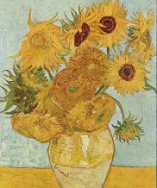
In a short period of ten years Van Gogh made approximately 900 paintings. Some of Van Gogh's finest works were produced in less than three years in a technique that showed his passion in brushstroke, in colour and in the movement of form and line. Dramatic, imaginative, and emotional, the artist was trying to explain either his struggle against madness or his understanding of man and nature.
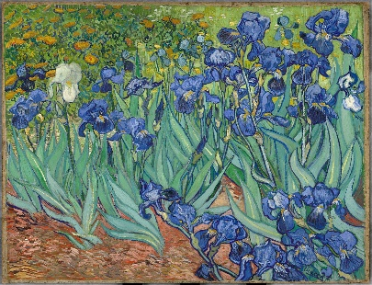
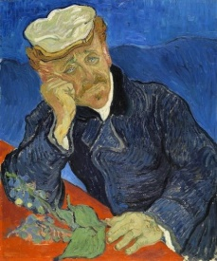
Van Gogh's influence on expressionism was enormous and can be seen in many aspects of art produced in recent years. Vincent’s brother’s wife collected Vincent’s paintings and letters after his death and dedicated herself to getting his work the recognition it deserved. It would not take long before his fame grew higher and higher. Today, several paintings by Van Gogh rank among the most expensive paintings in the world. On March 30, 1987 Van Gogh's painting “Irises” was sold for a record $53.9 million at Sotheby’s, New York. His “Portrait of Doctor Gachet” was sold for $82.5 million at Christie's, thus establishing a new price record.
Vincent van Gogh was also a passionate letter writer. Of the countless letters he wrote to his friends and family more than 800 have been preserved, as well as approximately 80 letters that he received. In one of his letters, he supports that “There are so many people, especially among our pals, who imagine that words are nothing. On the contrary, it’s as interesting and as difficult to say a thing well as to paint a thing.”
(Words: 253)

Statements |  | A | B | C
 |  | TRUE | FALSE | NOT MENTIONED
 | Van Gogh created all of his best paintings in less than three years.
 | Van Gogh used a technique that was different to all other painters’.
 | Van Gogh was suffering from some kind of mental illness.
 | Van Gogh tried to explain how he understood people and nature through his paintings.
 | Van Gogh’s influence can be seen even in art produced in our days.
 | Van Gogh’s brother’s wife devoted her life to promoting van Gogh’s work.
 | It took a long time for van Gogh’s work to become well-known.
 | Van Gogh's painting “Irises” was the only one sold at a record price.
 | Van Gogh wrote many letters to his friends who were also painters.
 | Van Gogh found writing as fascinating and as hard as painting.

ΘΕΜΑ 2^{α}. ΛΕΞΙΚΟΓΡΑΜΜΑΤΙΚΗ
Match each underlined word in the sentences below (11-20) with a word from the box that has a similar meaning (A-J). Use each word only once.
A. | approximately | B. | movement | C. | dramatic | D. | emotional | E. | collect
F. | deserve | G. | fame | H. | support | I. | especially | J. | receive

There has been a remarkable change in his character since he changed school.
Teachers always do their best to help their students in setting goals.
When shopping online, you can get your goods by post at home or at work.
His father earns around £150,000 per year, but he is not happy with his job.
Ants save food over summer in order to survive the winter.
I find some of Bach’s music deeply moving. It almost makes me cry.
These pieces of advice are particularly useful for new mothers.
The actress lived a life of celebrity, but never got used to it.
After all that hard work, you should get a holiday tip.
Some people run their lives according to the changes in position of the stars.

